Step-by-step to commit first project on Github.

1. Init repository version:

Open terminal in folder project.

* git init

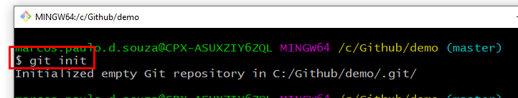

1. config e-mail git

* git config --global user.email [marcos.souza.anl@gmail.com](mailto:marcos.souza.anl@gmail.com)

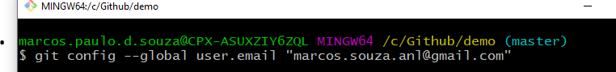

1. verify untracked files:

* git status

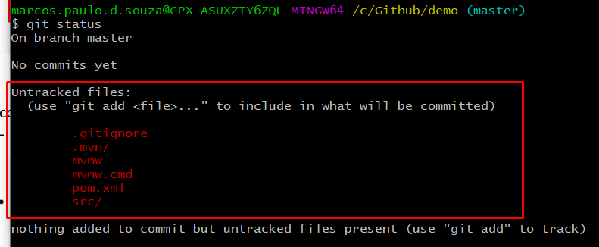

1. git add .

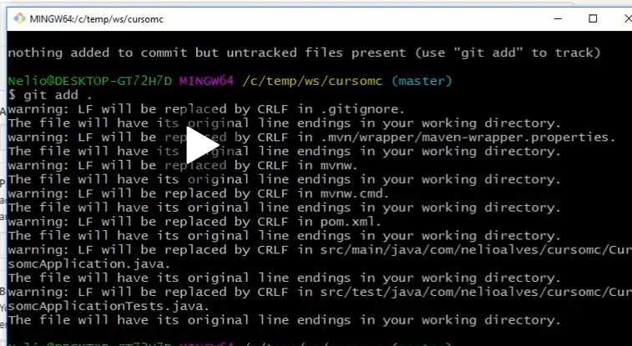

1. git status

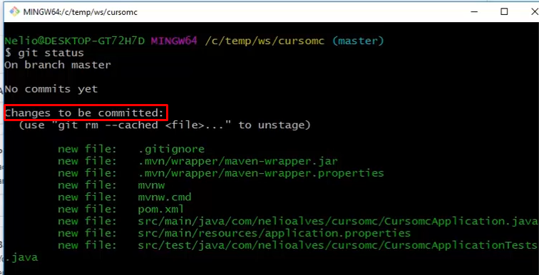

1. git commit -m “create project”

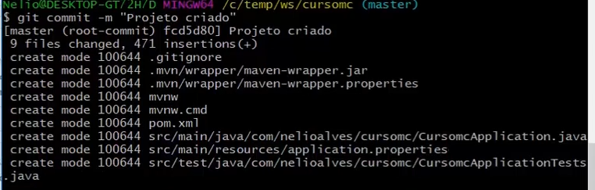

1. git log

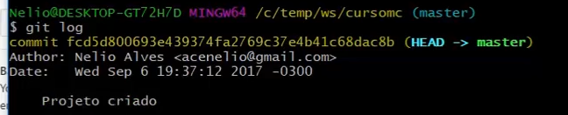

1. Create a new repository

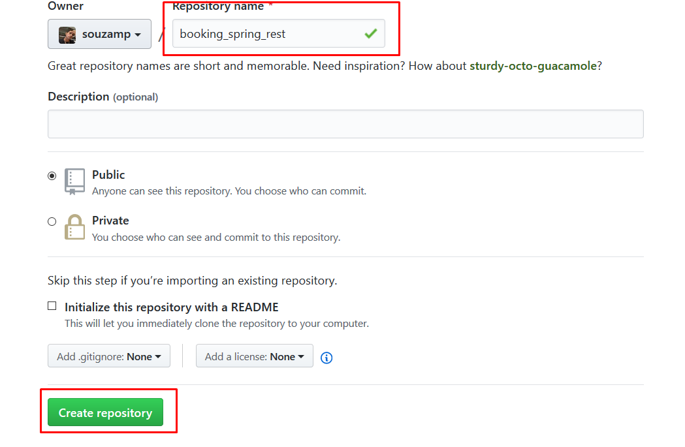

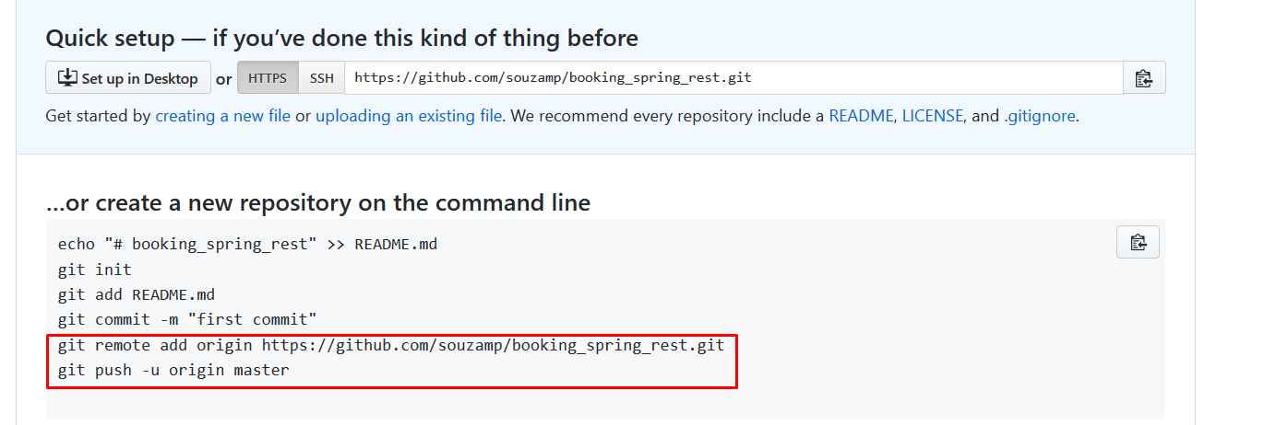

* git remote add origin <https://github.com/souzamp/booking_spring_rest.git>
* git push -u origin master